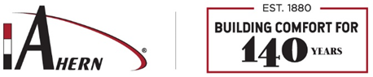

Drug Screening Protocol

Candidate Information:
Name: Click here to enter text. | DOB Click here to enter text.
Street Address Click here to enter text. | Phone Number Click here to enter text.
City/State/Zip: Click here to enter text. | Email: Click here to enter text.

☒ Urine Rapid Drug Screen 5 panel ☐ Post-Accident
☐ Urine Rapid Drug Screen 10/11 panel ☐ Reasonable Suspicion
☐ Urine Collection only Drug Screen 5 panel ☐ Random NDOT
☐ Breathe Alcohol Test

Occupational Health Services Available: Please mark service requested.

DER Information: Send invoices and results to below contact information
Company Name and Address: | Ahern  855 Morris Street Fond du Lac, WI 54935 This includes J.F. Ahern and Ahern Fire Protection
HR Requesting Screening: | Heather Holzman
Email Address: | aherncareers@jfahern.com – General Inbox for results  hholzman@jfahern.com- For Questions
Phone Number: | 920-913-6058 Direct Line; 920-907-5474 Fax

Clinic collection site & Candidate instructions: ESCREEN CLIENT ACCOUNT 721515-0
Clinic Name:

Address:

Phone Number:

Special Instructions:  See Drug Testing Clinic list | ☒ Bring Authorization form to clinic  ☒ Candidate states he/she is with Ahern  ☒ Present current photo ID (i.e. driver’s license) to clinic

